Hotwheels Sales Analysis

Overview

The project is undertaken to do some Exploratory Data Analysis & Visualization on past Dataset of Sales Data. This project is undertaken to do some findings that will help to give answers to certain questions.

Problem Statement

To identify the sales over 3 years (2003,2004,2005), identifying Top customer & which category is selling the most.

Technologies Used

1. MS Excel
2. Python
3. Power BI

Data Preprocessing

Python was used for Data Preprocessing. Here the raw data was loaded in Jupyter Notebook using Pandas Library. The next step was to understand the data like are there any missing values in the dataset also are there any outliers in the dataset. The Dataset had missing values in 4 columns (‘ADDRESSLINE2’, ‘TERRITORY’, ‘STATE’, ‘POSTAL CODE’) as these columns were not adding much value to the data analysis so all these four columns were dropped from the dataset. Once the missing values were taken care of the next step was to remove outliers. So the outliers were removed using Quantile (0.05 & 0.95) range all the rows failing to be between the quantile range were removed.

Data Model

Once the Dataset was preprocessed and cleaned, then that dataset was uploaded in Power BI. Power BI is used for Data Modeling & Visualization Process. In Power BI the flat Dataset file was divided, and Star Schema model was created using One to Many Relationship.

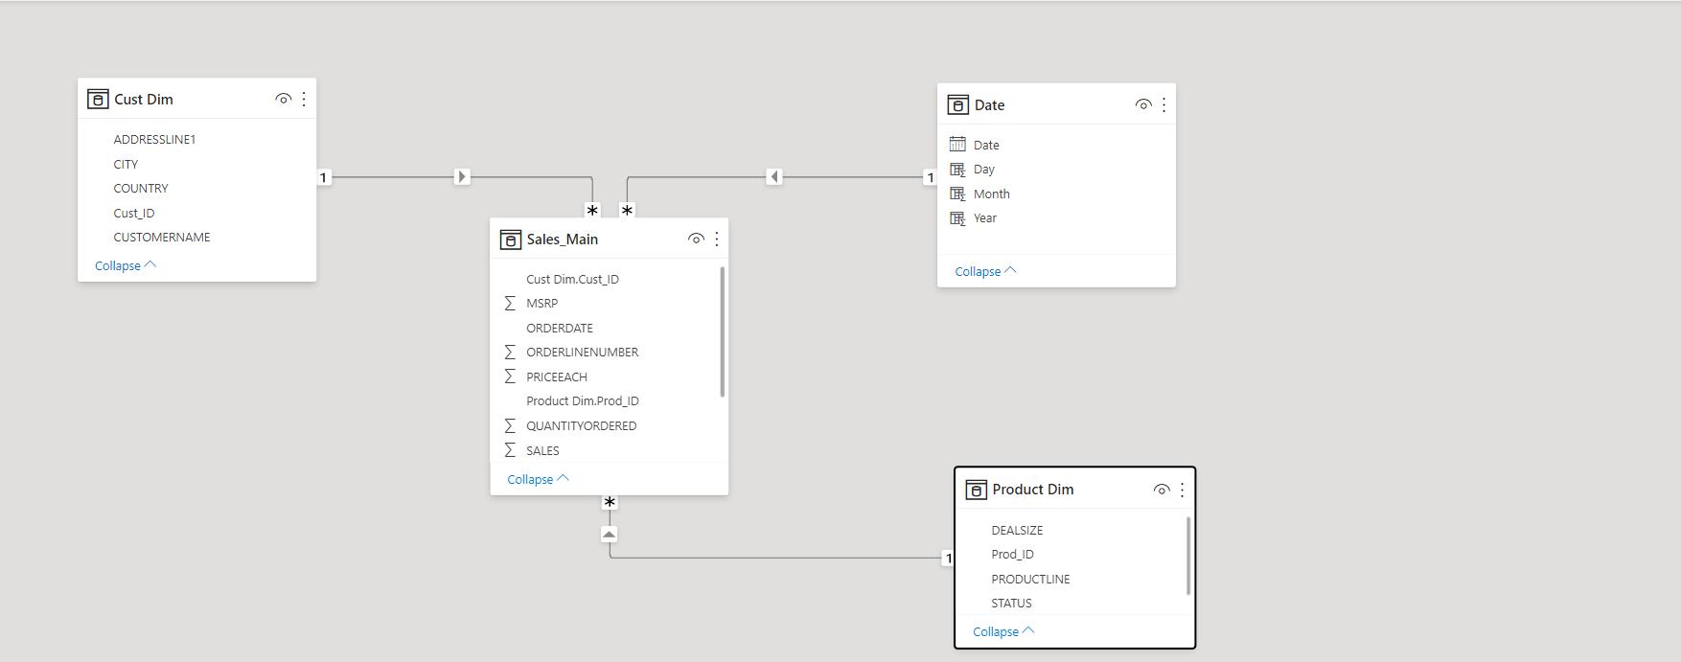

Result

1. From the Visualizations we found out that the sales from 2003 increased till 2004 but after that it has dropped drastically.
2. Medium Size Toys were ordered the most while Large Size Toys were least ordered.
3. Classic Car Model Toys were the highest selling toys and Trains were lowest selling toys.
4. Toys were sold all over the world but USA was Top ranked in buying toys while Ireland was last ranked.
5. Euro Shopping Channel was the best platform for selling the our Toys.

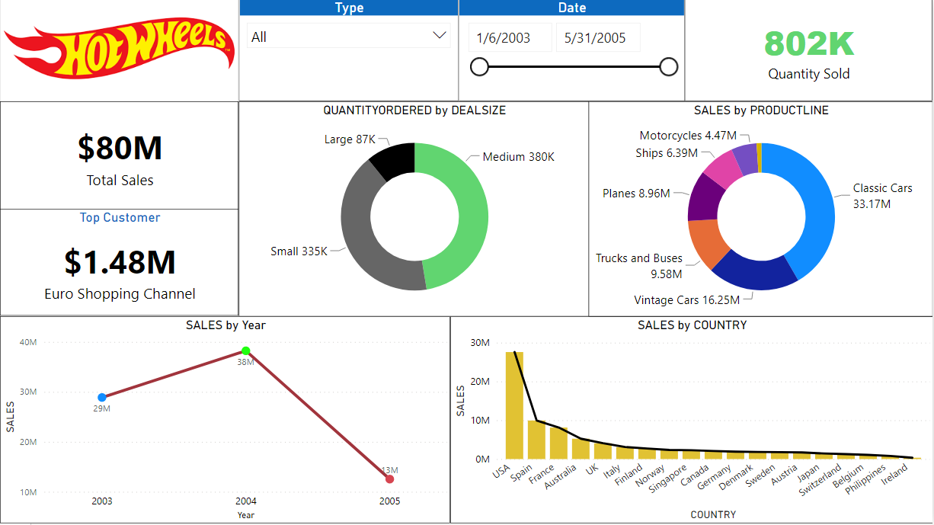

Conclusion

From the above analysis we found out that the sales in November are on Peak and best-selling year was 2004. Classic Car Medium Size model was the most sold toy, so it will be better to focus on that toy more to avoid any quantity shortage.